Lecture Note-04
Integration using Cauchy’s Residue Theorem (CRT)

Two main reasons account for the importance of integration in the complex plane. The practical reason is that complex integration can evaluate certain real integrals appearing in applications that are not accessible by real integral calculus. The theoretical reason is that some basic properties of analytic functions are difficult to prove by other methods. Complex integration also plays an important role in connections with special function, such as the gamma function, the error function, various polynomials and others, and the application of these functions in physics.

Cauchy’s Integral Formula:
If a function is analytic within and on a simple closed contour and if is any point interior to then,
- - - - - - - - - (1)
Special case : If is not an interior point of the contour then .
Differentiating n-1 times w.r.to
Definition of singular point (of an analytic function):
A point at which an analytic function is not defined, i.e., at which fails to exist, called a singular point or pole or singularity of the function.
Example 7.1: If then , 3 are the singular points of
Residue Finding Method:
If is analytic inside and on a simple closed curve C except at pole or has singularity at of order 1, then
.
If is analytic inside and on a simple closed curve C except at pole or has singularity at of order m, then

Cauchy Residue Theorem:
If is analytic inside and on a simple closed curve C except at a finite number of singular points inside C, then
Example 7.2: Evaluate by CRT , where C is the circle
Solution: For singular point,${\left(z-2\right)}^{2}=0$
Singular point $z=2$ is a pole of order 2. The point lies inside the circle .
Residue at the point is,
$Res\left(z=2\right)=\frac{1}{\left(2-1\right)!}\frac{d}{dz}{}$
$=\frac{d}{dz}{}$
$={}$
$=π.$
So by CRT we know,
Example 7.3: Evaluate the contour integral by CRT, where C is the circle
Solution: The poles or singularities of are as follows:  A pole of order 3 at . This pole lies inside the contour C.  Residue at the point of order 3 is given by  So by CRT we know, =0. | 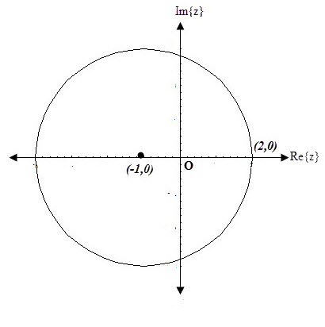
Sample Exercise Set on Cauchy residue theorem: 4.1

- (i) Find all the singular points of the following functions , $f\left(z\right)$and show the points in the argand diagram, where $f\left(z\right)$ =$\frac{1}{\begin{aligned}2z \\ \end{aligned}} , \frac{1}{z^{2}-4}$,$\frac{sinz}{z},$ $cotz and\frac{1}{z^{6}+1}$.
(ii) Find all the singular points of the following functions , f(z) and show them in the argand diagram,then find corresponding residues : $f\left(z\right)$ = $\frac{z^{2}+1}{z^{2}+z}$, $\frac{1}{\begin{aligned}z^{3}+i \\ \end{aligned}} ,$ $\frac{z^{2}+2}{z-4} and$ $\frac{1}{\begin{aligned}z^{6}+1 \\ \end{aligned}}$ .
- State Cauchy’s integral formula and Cauchy’s residue theorem (CRT). For each of the followings sketch the indicated path $C$ and hence evaluate applying Cauchy’s residue theorem (CRT) and Cauchy’s Integral Formula(CIF), ( if possible):
(a) $\oint_{C}{\frac{dz}{z-3i} }$, $C$ is the circle $\left|z\right|=4$.
(b) $\oint_{C}{\frac{e^{-z}}{{\left(z-1\right)}^{2}}}$, $C$ consists of $\left|z\right|=4$.
(c) $\oint_{C}{\frac{dz}{{\left(z-6\right)}^{10}} }$, where $C$ is the circle
3. Evaluate the followings applying Cauchy’s residue theorem (CRT) (if possible):
(a) Evaluate the integrals along the contour as given in the figures:
(i) $\oint_{C}{ \frac{2z}{(2z-i)^{3}}dz};​​$ (Fig. 1), (ii)$\oint_{C}{ \frac{dz}{z^{2}-1}};​​$(Fig. 2), (iii) $\oint_{C}{ \frac{2z-1}{z^{2}-z} dz};​​$(Fig. 3).

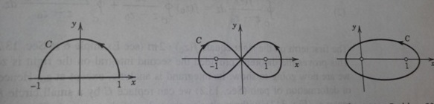
Fig.1 Fig.2 Fig.3
4. For the followings sketch the indicated path $C$ and hence evaluate applying Cauchy’s residue theorem (CRT) if possible:
(a) $\oint_{C}{ \frac{dz}{z^{2}+4}};​​$, $C$ is the contour as (i) $\left|z+2 i\right|=1$, (ii)$\left|z-2 i\right|=1$.
(b) $\oint_{C}{ \frac{cos\left(πz^{3}\right)}{(z-1)(z-2)}dz};​​$ where $C$ is the circle
(c) $\oint_{C}{ \frac{\sin{3}z}{(z-π)^{2}}dz};​​$ where $C$ is the circle .
(d) $\oint_{C}{ \frac{z+2}{z-2}dz};​​$ where $C$ is the circle $\left|z-1\right|=2$.

Reference Book: Advanced Engineering Mathematics (10th edition) by Erwin Kreyszig, Herbert Kreyszig, Edward J. Norminton, published by John Wiley & Sons, Inc

